**Okulumuz İngilizce Öğretmenlerinden FADİME TOK, 'BREAK YOUR CHAINS THROUGH SPEAKING’ adlı ' E-Twinning Projesine ARNAVUTLUK, İSPANYA ,BOSNA HERSEK VE TÜRKİYE 'den ortaklarla 01.01.2021 tarihinde başlamıştır. Projenin amacı öğrencilerimizi İngilizce konuşmaya teşvik etmek, farklı uluslarla kültür alışverişi yapmalarını sağlamak, İngilizceye karşı var olan önyargılarını kırmak ve İngilizce konuşma anlamında özgüven sahibi olmalarını sağlamaktır. Proje Nisan ayında sonlanacaktır. Öğrencilerin WEB 2.0 araçlarını aktif kullanmalarını sağlamak, İngilizce öğretimini eğlenceli hale getirmek projenin hedeflenen diğer amaçlarındandır. Proje ortaklarıyla sürekli iletişim halinde olunup düzenli çevrimiçi toplantılar gerçekleştirilmektedir.**

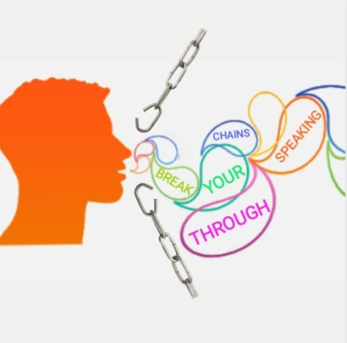

**ABOUT THE PROJECT**

**This project is aimed at students aged 14-18 years.  
Time frame: From January to the end of April in 2021.  
In this project, we will be able to learn why studens have trouble in speaking English and why they are reluctant. We want to help them overcome this problem and encourage them by giving positive feedbacks**

**AIMS OF THE PROJECT: As it is all known,students are reluctant to speak English in the class.It is actually a common problem and there are many reasons for it both psychological and cultural etc. In this project,we will be able to discover the reasons,find solutions together to encourage the students and promote their motivation to speak English.**

**WORK PROCESS: January: Firstly,we will analyse the reasons together why they have trouble in speaking English or why they are so reluctant.As far as we know from our teaching experience;lack of knowledge,confidence,motivation;fear of making mistakes are just some of the factors.  
February:After analysing the reasons,we will find the ways to enhance their speaking skills  
March:We will be able to make the class communicative, but how?Group activities,role plays,movies,songs and especially collaboration will help us at this point  
April:The more we minimize teacher talking time the more they find chances to produce the language. we will support them by giving positive feedbacks**

**EXPECTED RESULTS**

**At the end of the process, we believe students think that speaking English is not so diffucult, complex or not funny.They will change their attitude, overcome all the problems,trust themselves and enhance their speaking skills.**